**Week 8 Roman Imperialism and Government**

**Outline**

1. Incorporation of Sicily, Sardinia and Corsica.
2. *Provincia*.
3. Introduction of overseas provincial rule.
4. Increase in the number of praetors from 1 to 6.
5. *Prorogatio*
6. consuls > proconsuls;
7. praetors > propraetors;
8. magistrates > promagistrates
9. *Lex Sempronia de provinciis consularibus* of 123 BC: consular provinces were determined prior to the consular elections.
10. *Senatus consultum de Bacchanalibus.*
11. Senate, its function and prerogatives.
12. Administration of Roman provinces.

**Sicily, Sardina and Corsica**

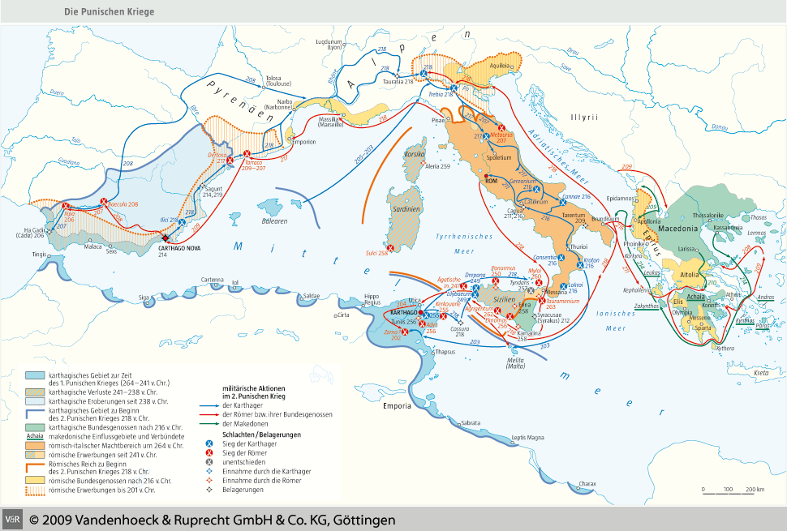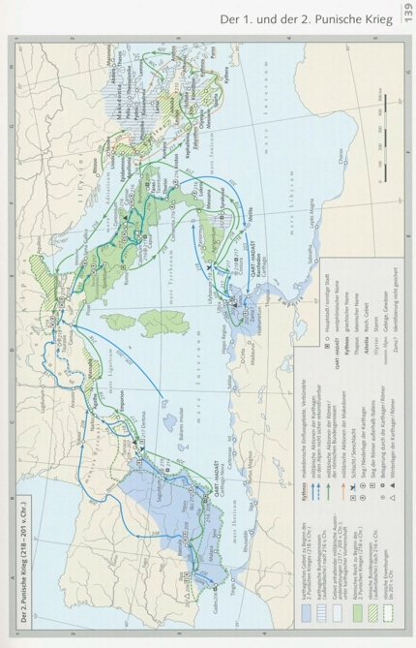Let us have a look in more detail at Rome’s incorporation of Sicily (241), Sardinia and Corsica (238) in the period **between the first and the second Punic Wars**; the administrative measure implemented by Rome in these areas differed from how it had dealt with the communities in Italy.

1. Acquire
2. Sicily

Sicily was acquired by Rome as a result of its victory in the First Punic War (264-241). The Carthaginians were forced to give up their military bases. The east coast remained under the control of Rome’s loyal friends: the city of **Messana** and the realm of **Hiero II of Syracuse (r. c. 271-215)**. It was annexed after the king’s death when his grandson Hieronymus abandoned the Roman allegiance.

1. Sardina and Corsica

In the wake of its defeat in 241, Carthage faced a fierce rebellion of its **mercenaries** in north Africa, which was quelled in 237. Mercenaries on the island of Sardinia had also begun to revolt. After the uprising in Africa had been subdued, Carthage turned its attention to Sardinia in an attempt to recover it. The rebels then **asked Rome for help**; it came and obtained control over Sardinia without having to fight Carthage, which submitted to Roman demands.

1. Administration
2. Praetor
3. Although little is known about the early Roman rule over these islands, from 227 these regions were placed under the rule of **praetors**: C. Flaminius (cos. 223, 217) in Sicily, and M. Valerius (Laevinus?) (cos. 220? 210; praetor 215) in Sardinia and Corsica.
4. Reasons for sending praetors

Praetors were Roman magistrates with *imperium*, like consuls; and thus able to **command armies**. Their dispatch seems to be connected to a desire to establish **a permanent Roman military presence** on these islands. The motives cannot be reconstructed with any degree of certainty, but might very well be related to a desire to **forestall the Carthaginians from regaining the island at a later time**, especially given that Carthage was expanding its rule on the Iberian Peninsula. Another reason might be related to **a need for jurisdiction** on the islands. **Taxation** might already have been levied from when Rome acquired these islands.

1. 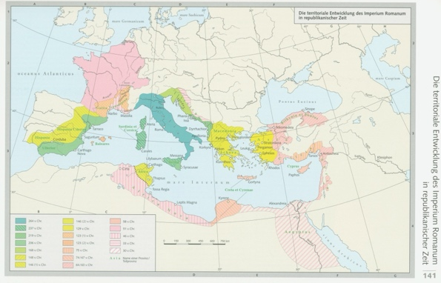Province
2. Name

* With the dispatch of praetors to Sicily and to Sardinia & Corsica, a new administrative instrument is introduced to Rome: overseas ***provinciae***(plural) of a more or less **permanent character**. The basic meaning of *provincia* is that of “**appointment**” or “**task**”. An overseas *provincia* thus indicated “**a sphere of operations assigned to a magistrate**” (A. Lintott, *Imperium Romanum*, London 1993, 23).
* The word acquired an additional meaning in the second century. When it indicated **a geographical area governed by a magistrate**, i.e., a territorial unit of Roman administration. The original meaning was never lost.

1. Management

* Provinces (whether sphere of operations or territorial units) were ruled by magistrates with *imperium.*
* **Praetors**: around 244 a second praetor had been created; in 227 the number was increased to 4 to secure a sufficient supply of governors for the provinces of **Sicily and Sardinia & Corsica**. In 197: increase to 6 to provide for governors of **Hispania Ulterior (Further Spain) and Hispania Citerior (Nearer Spain)** provincial governors.
* **Consuls**
* When Rome created new provinces, it dispensed (供应) with creating new praetors; instead, the *imperium* of a consul or praetor was prorogued (延期，***prorogatio[1]***), i.e., extended after their year in office to serve in a province for one or a few years. These governors then held the rank “instead of a consul” or “instead of a praetor”, i.e., as **proconsul** or **propraetor**. Proconsuls and propraetors are collectively designated as **promagistrates**.
* The praetorian and consular provinces were generally determined by the **Senate** at the **beginning** of the new year. The provinces were then allocated by lot to the praetors and consuls, although the consuls could also determine the province by **mutual agreement**.
* The *lex Sempronia de provinciis consularibus* of 123 BC altered the time at which the consular provinces were determined to the period **prior to the consular elections**.

**Senate**



1. Main Characteristics
2. Early history shrouded in mist.
3. Initially council of **kings**; later of Rome’s **chief magistrates**; yet, at the same time the Senate was autonomous.
4. Powers and prerogatives were grounded in custom: *mos* and *consuetudo.*
5. **Advice** covers domestic/foreign policy, finance, religion.
6. Prerogatives
7. **Prior advice** of the Senate **before proposal of bill to People’s Assemblies** was based on custom.
8. Senate could **invalidate** laws already passed.
9. 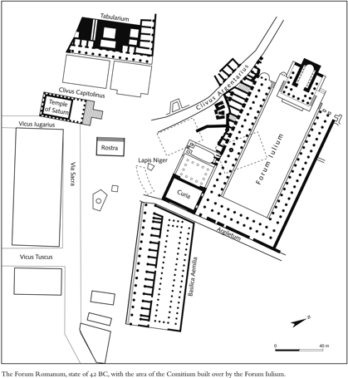Senate was the only **permanent** political body in Rome. It gained control over finances, levy of troops, allocation of provinces, external relations, law and order in Italy, communal religion during **the 3rd and 2nd centuries BC**.
10. Composition and recruitment
11. Little is known of its composition from earlier times, but it probably consisted of **patricians** and **plebeians** (in a very early age), given that senators were addressed *patres et conscripti*. The *patres* were the patricians; the *conscripti* were not.
12. For the early Republic, we know little about the recruitment of senators. Their number was probably **lower** than during the second century BC. It is nevertheless doubtful if during the early Republic senators were former magistrates (as was the case during the late Republic). The number of magistrates was low; iteration was common. Consuls seem to have had a hand in **selecting senators**. The Senate thus appears to have been an ***ad hoc* council** until the *lex Ovinia.*
13. The earliest known occasion of the implementation of **fixed criteria** is the passing of the *lex Ovinia* (c. 339/318 BC): **censors** were to draw up a list of senators. Serious misconduct could lead to omission from the list, and disgrace. This law probably introduced the practice of **automatic membership** of **ex-magistrates** (consuls, praetor, dictator, possibly aedile). But there is no record of the criteria. Some elements are clear, though:
14. Additional members could be enrolled at the census.
15. Membership of the **equestrian** order (property of 400,000 sesterces).
16. 300 members (late 2nd century BC); perhaps 600 under Sulla; possibly 900 under Caesar’s dictatorship; 600 under Augustus.
17. *Lex Atinia* (sometime 122-102 BC) may have granted admittance to the Senate to the People’s **Tribunes**.
18. From Sulla’s time onwards **quaestorship** qualified for Senate membership.
19. *Senatus Consultum* (Senatorial Decree)
20. Characteristics
21. During the Republic, it **lacked** legal force.
22. Nevertheless, almost always followed.
23. Structure/Contents
24. Name of the presiding magistrate.
25. Statement by the proposing magistrate, ending with the formula *de ea re ita censuerunt* (“concerning the matter in hand they decreed as follows”).
26. Decree itself, generally expressed in the form of an advice.
27. Mark of approval: *censuerunt* (“they decreed”).
28. Archiving
29. The decrees were deposited in the *aerarium*.
30. Copies were kept by the **plebeian aediles** in the Temple of Ceres.
31. Example: *Senatus Consultum de Bacchanalibus*

**Socio-Cultural Developments in Third and Second centuries BC**

1. Culture

In **middle of the third century BC**, Greek cultural influence on Roman society became firmly established—in a period **before** the political expansion of Rome into the eastern Mediterranean. This is reflected in art, architecture, literature (**epic**—e.g., L. Livius Andronicus, c. 280/70-200, writing a Latin translation of the *Odyssey*, also tragedies and comedies, Cn. Naevius, c. 280/60-200 (also drama), Q. Ennius, 239-169; **drama**—e.g., playwright T. Maccius Plautus, end of third century, P. Terentius (Terence) Afer, first half second century; and **historiography**—**M. Porcius Cato**, 234-149, e.g., *Origines*; Q. Fabius Pictor had written in Greek).

1. Pliny, *Natural History* 34.7.13: *Porticus Octavia*

VII [13]. In early times the lintels (门楣) and folding doors of temples as well were commonly made of bronze, I find that also Gnaeus Octavius [praetor 168, consul 165] who was granted a triumph after a sea-fight against King Perseus, constructed the double colonnade (双柱廊) [i.e. 167] at the Flaminian circus which owing to the bronze capitals of its columns has received the name of the **Corinthian** portico, and that a resolution was passed that even the temple of Vesta should have its roof covered with an outer coating of **Syracusan** metal.

1. **Bacchanalia**
2. Key characteristics

* Origins: Greek cities in southern Italy.
* Spread: throughout Italy, especially the centre and south.

1. Suppression of the cult

* *SC de Bacchanalibus* and Livy; *tresviri capitales*

1. Motivations of the suppression

* The **disruption** of traditional patterns of family life caused by the oaths of loyalty, the organization, funding and leadership of the cult centers.
* Possibly also the idea that the organization of the cult might undermine or develop into a **politically disruptive element**, just like certain other *collegia* have been a disruptive force in Roman politics (e.g., riots in the People’s Assemblies).

1. Aftermath

Little is known.

1. Population

Roman population changed significantly as a result of **the spread of citizenship** (through grants to entire communities and manumission of slaves).

1. Religion

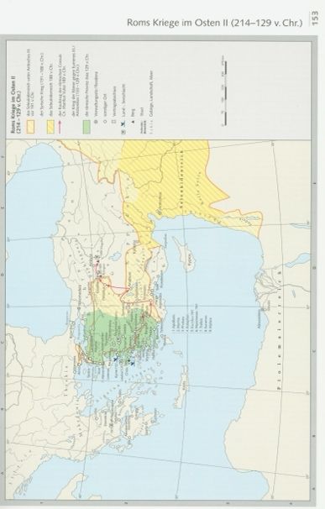As in earlier years—prior to the conquest of Italy—Romans displayed a preparedness to accept **foreign cults and religious practices**; there seems to have been no sign—at least in the third century BC—of this development undermining the Roman nature of religion. Best informed are we about innovations during the Punic Wars, which were much less a reflection of **panic** or the unusual as of established attitudes: *Cybele* (*Magna Mater*) was brought to Rome in 205/204 after consultation of the **Sibylline Books**.

**Administration of Roman provinces during the Republic**

1. Governors
2. Initially all the provinces were administered by **praetors** who would be in charge of a province allocated to them during their one-year term in office. Their main tasks were **defense of the province** and **the execution of justice**.
3. Governors had a small staff including a **quaestor** (for financial purposes).
4. Local administrative system was largely **retained**.
5. Taxation
6. Tax collection was performed by local administration and handed over to the quaestor or to ***publicani***(singular: ***publicanus***), who mostly designated men of **equestrian** rank (i.e., one rank below that of senator) who had gained the right to collect taxes on behalf of Rome in a province.
7. That does **not** mean that Rome in each province depended on such *publicani* for the collection.

1. *Prorogatio* was a procedure performed, until Sulla’s *lex Cornelia de provinciis ordinandis* of 81 BC by the senate and/or people’s assembly.